<!DOCTYPE html>
<html lang="en">
<head>
<meta charset="UTF-8">
<meta name="viewport" content="width=device-width, initial-scale=1.0">
<title>My Budget Tracker</title>

<link rel="stylesheet" href="style.css">
</head>

<body>

<header>
<h1>My Budget Tracker</h1>
<p>Track your income and expenses in one place.</p>
</header>

<main>

<!-- Add Expense Section -->
<section id="add-expense">
<h2>Add Expense</h2>

<label for="expense-name">Expense Name:</label>
<input type="text" id="expense-name" placeholder="Enter expense name">

<label for="amount">Amount:</label>
<input type="number" id="amount" placeholder="Enter amount">

<label for="category">Category:</label>
<input type="text" id="category" placeholder="Enter category">
</section>

<!-- Your Expenses Section -->
<section class="expenses">
<h2>Your Expenses</h2>
<p>No expenses yet.</p>
</section>

</main>

</body>
</html>

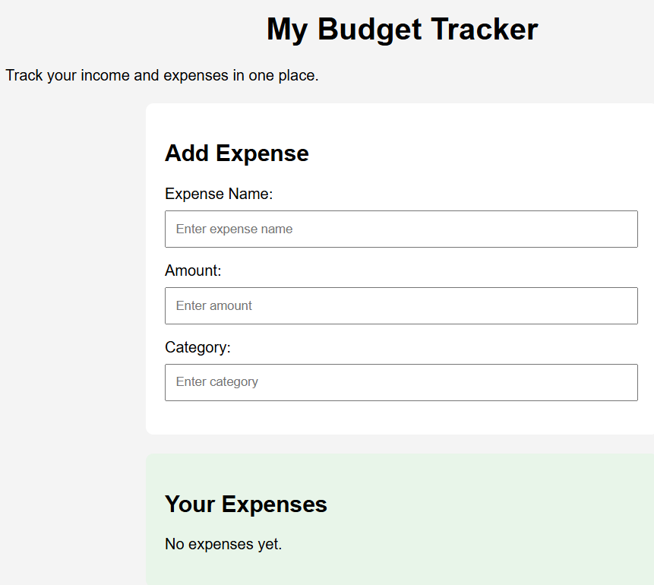

/* Element selector */
body {
font-family: Arial, sans-serif;
margin: 0;
padding: 20px;
background-color: #f4f4f4;
}

/* Element selector */
h1 {
text-align: center;
font-size: 32px;
}

/* ID selector */
#add-expense {
background-color: white;
padding: 20px;
margin: 20px auto;
max-width: 500px;
border-radius: 8px;
}

/* Class selector */
.expenses {
background-color: #e8f5e9;
padding: 20px;
margin: 20px auto;
max-width: 500px;
border-radius: 8px;
}

/* Element selector */
input {
display: block;
width: 95%;
padding: 10px;
margin: 8px 0 15px;
}

